**Cash Loan Revamp Strategy Documentation**

The **segmented ACL** project’s primary objective is to create Risk Based Offers (max Credit Limit and Max Tenor) in the Loan Calculator Page, so that we can offer higher ticket size to less risky users and lower ticket size to high-risk users. While we will be using the Offer Store Infrastructure to manage these Loan Parameters per Risk Segment, these offers will NOT be pre-approved offers like Upsell. All the users will have to apply for the loan and thereafter must go through the Taran Journey for Credit Decision.

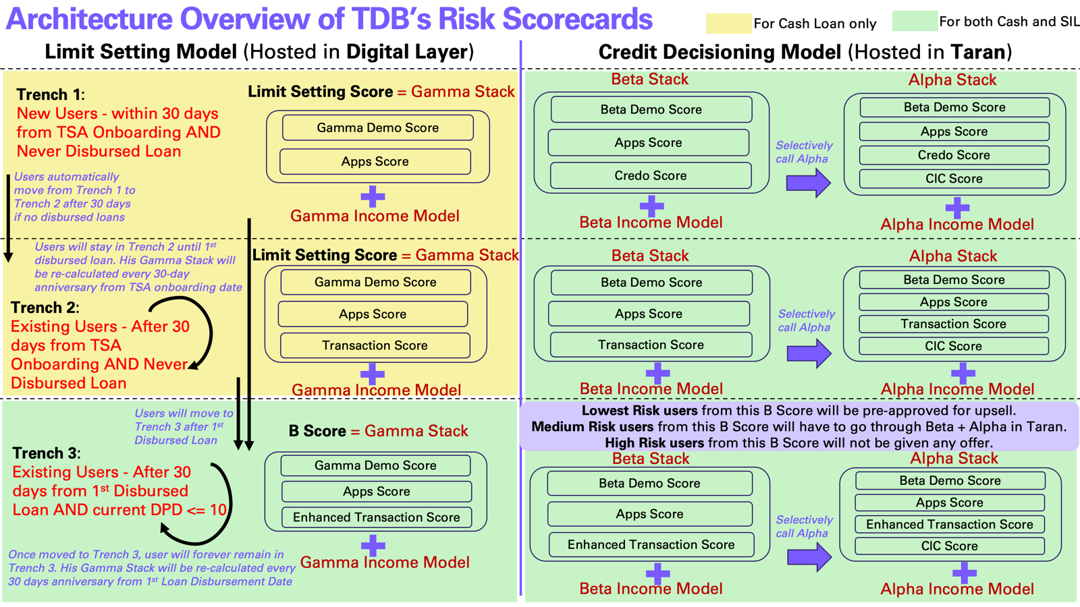

1. **New Flow New Users (All of Trench 1 Users):**

The New Onboarding Flow means users will have to answer 4 additional questions during onboarding: Marital Status, Self-Declared Income, Number of Dependents and Education Level. Based on this onboarding info, Credo Score and Credo Raw Data, Digital Layer will call the Gamma API immediately after the TSA Onboarding is completed. Digital Layer should call Credo API sometime BEFORE the TSA onboarding complete stage (e.g. customer profile creation time) to make sure Credo Score and Credo Raw Data is already available when the customer finishes TSA Onboarding.

With all this information in hand, DL will create the JSON file and call the Gamma API.

Gamma API will return < Risk Segment, Gamma Stack Score, Gamma Individual Model Scores, Loan Offer Parameters: [Min Credit Limit, Max Credit Limit, Monthly Interest Rate, Min Tenor, Max tenor, Offer Validity] >

Note:

* If Credo API does not return anything or times out, Digital Layer will NOT be able to call Gamma API.
* If Gamma API times out, the Digital Layer will show something generic in the Loan tile of the landing page but internally will call the Gamma API again so that the offer gets generated and can be shown to the user when she comes back to the Landing page next time.

Digital Layer will receive this API results and store it in Offer Store first, and from there the offer will be shown to the Loan Calculator UI.

Note:

* The offers generated will be ONLY CASH LOAN OFFERS, no SIL offers will be shown for this Segmented ACL project at least at launch. In future we will explore if it makes sense to create offers for SIL as well. But it is out of scope for the current build
* For unlendable segment show the BAU Credit Builder workflow, i.e. keep doing Biller transactions and/or make some deposits before they can get small ticket loan offers from us. There will be no offers shown for this unlendable user's segment.
* Digital Layer should create MoEngage events for the new 4 new questions in the Onboarding flow

To start with the default Offer Validity will be 30 days, as we will be scoring the customer again after 30 days (to be more precise, we will score the customer again on the very next day from her current offer expiry date). New generated offers are usually updated in the offer store table and in the UI the next day based on the current set up.

<*Attn Risk Team: Risk team will have to create separate Threshold for this Gamma Stacks as this Gamma Stack at Onboarding (or Trench 1 Gamma Stack) will NOT have any Transaction Score component*>

1. **New Flow Existing Users (Trench 2 users):**

New Flow New Users after 30 days on book (30 days from TSA onboarding date) will automatically become New Flow Existing Users. From them, we will score ONLY those customers, who do not have any disbursed loan yet (as of the Score calculation date).

For these users those 4 additional fields from New Flow (Marital Status, Self-Declared Income, Number of Dependents and Education Level) will already be available. We will still take their latest available information for the scoring process as follows:

1. If the customer has already applied for any loan before the score calculation date, we will take the latest demographic information from that loan application journey (if there were multiple loan applications before, we will take the last loan). If the customer did not apply for any loan before the score calculation date, we will take the demographic data as per the onboarding journey.
2. We will take the latest Credo Score and Credo Raw Data as per the latest available Credo run date. This section will require IT Development:  
   àIdeally the latest Credo run date should be within 30 days before the Score calculation date.   
   One way to increase credo calls within last 30 days will be for Digital Layer to call the Credo API every time the user opens the Tonik app and goes to the landing page (Dashboard page) given the last Credo run date is not within last 30 days (from the App opening date).

à Since we have unlimited Credo Calls now, for every Loan application journey however, Digital Layer should always call Credo API to use the freshest Credo data to make the loan decision. There is no point in using even 30 days old data for Loan Approval purposes.

1. We will also take their latest transaction data (cash in, cash out, bill payments, deposit transactions, loan application transactions etc.)

The data team will create a Cron job in the Data Lake that will use the above data points and calculate Gamma Stack Scores for these users (Trench 2 Gamma Stack Score). This Cron job will be first called on 30th day anniversary from the user’s TSA onboarding date, and thereafter on the next day from offer expiry date until the user does takes up the offer. If the user who received an offer does not take the offer, then the next offer will be generated on the very next day from her offer expiry date and the new offer will be shown on the next day (from previous offer expiry date).

Note:

* Users who have a rejected Loan application within last 90 days from the Scoring date, will not be scored, and hence no offers will be generated for them to maintain the 90 days cool off period
* If for some reason the Cron job run fails, it will be triggered again (after fixing the issue that caused the failure) and the offer date and offer validity will be generated accordingly.
* This whole process will be a Backend driven process, so the customer will not know anything or face any kind of delay. They will just see the offers as and when they are generated

1. **Old Flow Existing Users (Trench 2 users):**

Users who have joined Tonik through Old onboarding flow (without the 4 new questions) and > 30 DOB, will be of two categories:

1. **Users who never applied for any loan** **before**: For them we will not have those 4 feature values. We will create a UI pop up for the user to fill in those details, but most users will probably not fill them or will take time to fill them. Hence a pragmatic approach will be instead of waiting for the users to provide us with those 4 feature values, we will score them anyways without those 4 features.   
   * Self-declared Income (most important feature) *// this feature will be available for all Existing users as it is currently mandatory to fill in within 30 days from TSA onboarding, no impact*
   * Education level (4th important feature) // *this feature will be missing, small impact*
   * Marital Status (7th important feature) // *this feature will be missing, very small impact*
   * Number of Dependents (Not used in the current version of Demo model) // *this feature will be missing, no impact*

We can still generate the Demo Score without these 3 features, it will be a bit less predictive than the regular Cash Gamma Demo model. We will still get some good predictiveness from the Apps Score and Credo Score models, so the overall impact on the Gamma Stack model will not be so much. < *Attn Risk Team: Only thing is Risk Team will have to create a separate Threshold for this group of users.* >

Note:

* We will continue to show the pop up for those users until they fill it in or until they reject filling it in (*pls check with product team if this additional KYC info will be optional or mandatory?*), even if we score them in the backend without 3 features.
* **The moment the users fill in those additional KYC information, Digital Layer will just update the details in the Data Lake but will NOT call the Gamma API immediately or will NOT re-create the offer in real time. After the expiry of the current offer, Backend will re-create the offer using the updated information and that will be shown in the UI.**

1. **Users who have applied for any loan before:** For them we will already have those 4 feature values. Hence, we will score them the same way as New Flow Existing Users (Section B).

Please note that having the latest Credo Data will play a crucial role in generating these scores as well. So Digital Layer should make sure to fetch the latest Credo Scores every time the user lands into the Dashboard page of the app, given that the last Credo Run Date was not within last 30 days.

**Special Note on Credo Calls and the impact of the recency of Credo Data on the Stack Model:**

For Loan Application flows, always call the Credo API irrespective of whether we had a credo run date within the last 30 days. Because for Loan applications, the freshest Credo Data is critical.

For Creating Offers, Credo Data should be ideally fresh within the last 30 days. Hence, we will have to keep calling Credo when the user lands on the Dashboard page if the last Credo call was not within last 30 days. If the user did not apply for a loan within last 30 days or did not open the Tonik app and visited the Dashboard page, then we will have a few options: <*Attn Risk Team*>

1. **Option 1**: We will not score the user if the user’s if the Credo Run Date is not within last 30 days (from the score calculation date)
2. **Option 2**: We will score the users if their Credo Run Date is within the last 60 days (from the score calculation date) and will deploy a different Threshold for the Gamma Stack Score for them.   
   If the last Credo Run Date is more than 60 days behind, then we will not score these users
3. **Option 3**: We will score the users if their Credo Run Date is within the last 90 days (from the score calculation date) and will deploy a different Threshold for the Gamma Stack Score for them.   
   If the last Credo Run Date is more than 90 days behind, then we will not score these users.

The risk team can decide which option to go with after they run the simulations with the Back Scored data.

**Counter Offer**

**Question: Who will be the eligible customers for generating the Gamma Stack Score?**

**Answer:** Eligibility criteria for generating Gamma Stack Score:

1. Customer must not have ANY disbursed loan as per the score calculation date
2. Customer must not have ANY submitted loan application pending decision as per the score calculation date
3. Customer must not have any active offer or non-expired offer as per the score calculation date
4. Customer must never be tagged for Fraud or Blacklisted before
5. Customer must not be rejected for any type of Loan Application with Tonik within last 90 days

**Question: Will we continue to generate offers indefinitely or should we stop after 6 months (as we currently do for Upsell offers if there is no take-up)?**

**Answer:** We will continue indefinitely if we can. Ideally all non-loan customers should always have a loan offer readily available for them. In future, may be 6 months after the new flow stabilizes, Growth and Risk team might want to create special promotional offers where they can give a one-time higher Credit Limit or one-time lower interest rate offer to select customers as an experimental basis to push for higher take-up rates.

**Question: What will happen to the ongoing loan application when a new offer is generated?**

**Answer:** If the customer started the loan application using a previous offer (which is currently expired) and the customer did not submit the application, then that unfinished application should be automatically expired. The customer must use the new offer to start a new loan application.

However, if the customer has an unfinished organic loan application (that did not originate from any offer), please check with the Product team if we should expire those loan applications before we can generate a new offer.

**Question: What will happen to those pending registrations users after we launch the new onboarding journey?**

**Answer**: We will have to reset their registration process if it is not completed and guide them to complete the new onboarding process. Check with Product team on the details.

**Question: Will we need to call the GCP to re-generate the score and new offer when the user updates her profile information through the app on her own?** (not from the pop up shown for Old Flow Existing users who never applied for loan before)

**Answer**: NO. If we do this, then the customers can potentially game the system by inflating their profile information to get a better offer. Hence, for voluntary manual updates of the profile information, we will not re-score the customer immediately. We will let the current offer expire. Then we will re-calculate the score based on the latest available profile information.

A Thumb rule for re-calculating the score is: For voluntary KYC profile information updates we will NOT re-calculate the score. But for KYC profile information updates triggered by the TDB, we will re-calculate the score and regenerate the offer immediately.

**Question: What happens to those users whose Credo Information is not updated within the last 90 days?**

**Answer**: Credo data (Credo Score + Apps Score) is the most predictive component of Gamma Stack Score. Hence, we can’t generate Gamma Stack Score if this Credo data is stale, i.e. more than 90 days old. We will not score those users, and we will not generate any new offers for them.

We can probably continue to show the same last offer to the customer if there was an offer created before for her. If no offer was created for the customer, then maybe we can show the BAU Loan parameters (max 20K Pesos)

**Question: What happens to those users for whom we could never generate the Gamma Stack Score, and the user still does not have any disbursed loan?**

**Answer**: If the customer is an eligible customer, and not an Unlendable customer and yet no offer has been generated for the customer, then show the BAU Loan parameters for them on the Loan Calculator Page, i.e. max credit limit = 20K Peso. However, we will make every effort to score the maximum number of customers without disbursed loans.

**Question: Will there be any SIL offer for these Risk Segments?**

**Answer**: Not in Phase 1. As the name of this project (Segmented ACL) suggests, we will focus on primarily ACL for this go-live.   
  
After we go live and the flow stabilizes, we can introduce SIL offers as well for this Risk Based Segments. However, please note that it will need significant change in the process and Promoter training, as the Segmented ASIL (Acquisition SIL) will probably have a different flow, where the Max Credit limit will not come from Purple App, but from user’s Tonik App. Please check with Product team for the plan and more details on this.

**Question: Will you re-score the unlendable segment after 30 days?**

**Answer**: Yes, we will re-score the unlendable segment after 30 days. Some of them may come out of unlendable category based on their latest Credo Data or latest Transaction Score.

**Question: Will unlendable users be able to apply for Cash Loan?**

**Answer**: NO. There will be no Cash offer shown for them on the Loan Calculator page.

However, these customers can still apply for SIL organically or can join the Credit Builder Program. If these users apply for SIL organically, we don’t need to stop that application. The Beta Model will be able to handle those users (Beta Model is a superior model than Gamma model...hence no need to worry!)

**Question: Will you launch ACL Segmentation for 100% of the users at launch?**

**Answer**: NO. We always launch in pilot mode, which means, we will change the onboarding flow (add those 4 mandatory questions) for ALL the new users, however we will launch the Segmented ACL only for 10-20% of the users in the beginning, remaining 80-90% ACL flows will be BAU flow, i.e. the users will see Max 20K Peso Credit Limit in the Loan calculator page. After ~1 month from pilot launch, we will scale up the Segmented ACL.